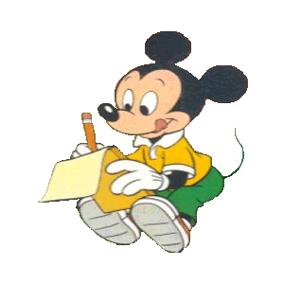
Cvičenia na rozvoj čítania: rozlišovanie znakov

Hľadaj rozprávkové postavy. Značka víly ti prezradí jej meno. Napíš ich.

K | P | B | U | O | L
M | B | P | O | P | A
L | X | V | E | M | S
H | Á | Ž | O | R | Y
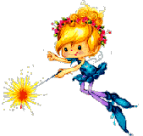

______________________________

M | S | U | B | K | O
A | Ž | M | O | A | B
D | K | A | F | J | B
K | A | H | G | R | A

______________________________

S | U | N | I | J | E
Š | H | T | U | R | G
L | P | I | V | E | C
A | N | O | K | Y | A

______________________________

L | P | Y | O | S | V
B | E | P | M | O | U
L | G | U | V | K | Š
S | D | K | O | A | C

______________________________

U | D | J | L | A | N
T | M | K | R | B | O
H | Á | Z | R | U | A
G | Š | O | K | F | O

______________________________

