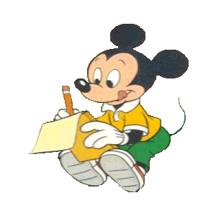
Cvičenia na rozvoj čítania: rozlišovanie znakov

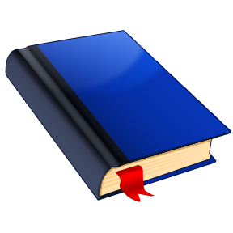
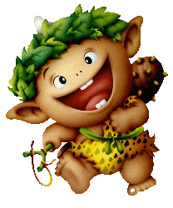
Značka ti prezradí názov rozprávky. Značka škriatka ukrýva meno postavy z nej. Napíš ich.

Č | P | E | V | O | R
M | V | P | O | E | A
L | N | V | Á | M | Č
I | M | A | K | P | Y
O | G | Č | U | K | A

______________________________

______________________________

S | P | U | B | O | M
A | Ž | P | C | A | B
O | K | L | A | O | B
C | U | H | Š | R | K
G | A | D | A | U | Y

______________________________

______________________________

Š | U | Z | I | K | E
L | H | T | A | R | T
L | Á | I | P | E | R
I | A | A | K | T | D
O | K | V | K | A | B

______________________________

______________________________

Č | K | A | O | S | R
B | O | C | D | Ú | N
R | E | G | V | K | J
Č | N | I | Í | Ž | M
S | Á | K | C | H | E

______________________________

______________________________

